30.12: a) 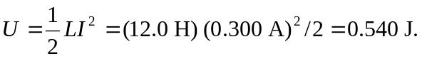
b)
c) No. Magnetic energy and thermal energy are independent. As long as the current is constant, 

